Adventist University of Central Africa

EDUCATION INSIGHT SUPPORTING HUB
CASE STUDY: ADVENTIST UNIVERSITY OF CENTRAL AFRICA (AUCA)

A final project
presented in partial fulfillment of the
requirement for the degree of
BACHELOR OF SCIENCE IN INFORMATION TECHNOLOGY
Major in
NETWORKING AND COMMUNICATION SYSTEM

by
NTAGANIRA Darcy
May, 2024

PROJECT ABSTRACT
Research Project for the Bachelor Degree in Information technology
Emphasis in Networking and Communication Systems
Adventist University of Central Africa

Title: EDUCATION INSIGHT SUPPORTING HUB (CASE STUDY: Adventist University of Central Africa)
Name of this researcher: NTAGANINRA Darcy
Name and the degree of the faculty advisor: Dr. SEBAGENZI Jason.
Date completed: May, 2024

This project work automates Education Insight Supporting Hub. In this thesis Web based application is developed.

The web application Set up an early warning system that identifies early signs of academic struggles or social issues. Trigger alerts for teachers, counselors, and parents when a student is flagged by the system. Create profiles for each student, including academic history, attendance, behavior records, and social interactions and Facilitate communication and collaboration among teachers, counselors, and parents.
The system also facilitates to utilize behavioral analysis to identify potential social challenges, including bullying, isolation, or emotional distress. Enable timely interventions by counselors and support staff.
Integrate a survey module to gather feedback from students on their academic experience and well-being. Use feedback for continuous improvement of support strategies. Generate reports and historical trends to identify patterns and areas for systemic improvement in the education system.
The system functionalities have been tested with data from AUCA. It has been observed that the system successfully satisfying the requirements. It has also been shown that the system facilitates users using internet because it is an online system. System front end developed using HTML, CSS, and JavaScript. This will assist us in: create responsive and interactive user interfaces and for back end, PHP framework and MySQL database were used.

PLAGIARISM REPORT

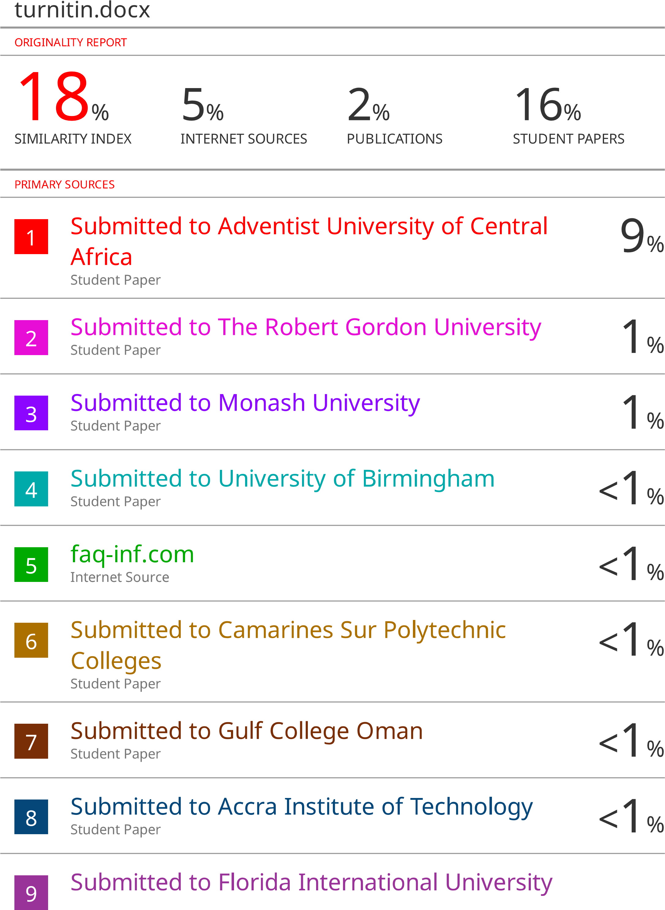

DECLARATION
I, NTAGANIRA Darcy, hereby declare that this project titled “Education Insight Supporting Hub” is the work that I have spent a lot of time researching and working on and have not yet received any credit from the Adventist University of Central Africa or any other institution.

Signature: _____________________________
Date: _____________________________

APPROVAL
I, SEBAGENZI Jason, hereby certify that this project report has been done under my supervision and submitted with my approval.
Signature …………………………..
Date……………………..

DEDICATION

God who helped me carryout this project from start to finish.
My parents who supported me throughout the project.
My siblings who were my biggest cheerleaders.
My lectures and supervisor who provided me with guidance
My friends who were my support systems.
My classmates who were sources of ideas and inspiration.

TABLE OF CONTENTS
PROJECT ABSTRACT i
PLAGIARISM REPORT ii
DECLARATION iii
APPROVAL iv
DEDICATION v
LIST OF FIGURES ix
LIST OF TABLES x
LIST OF ABBREVIATIONS xi
DEFINITION OF TERMINOLOGIES xii
ACKNOWLEDGEMENT xiii
CHAPTER 1 1
GENERAL INTRODUCTION 1
Introduction 1
Background of the study 2
Problem Statement 2
Motivation of the study 2
Objectives of the study 3
General objective 3
Specific objectives 3
Scope of the study 3
Methods and Techniques used in the study 3
Observation 3
Documentation 4
Interview 4
Expected results 4
Organization of the report 4
CHAPTER 2 6
ANALYSIS OF THE EXISTING SYSTEM 6
Introduction 6
Description of the Existing System Environment 6
Historical Background 6
Mission 6
Vision 7
Description of the Existing system 7
Analysis of the existing system 7
Modeling of current system 7
Problems of the Existing system 8
Proposed solutions 8
Requirement Specifications 9
Functional requirements of the proposed system 9
Non-Functional requirements of the proposed system. 10
CHAPTER 3 11
REQUIREMENTS ANALYSIS AND DESIGN OF THE NEW SYSTEM 11
Introduction 11
Analysis and Design Methodology Object-oriented Methodology (OOM) 11
Unified modeling language (UML) 11
UML models 12
Design of the new system 12
Use Case Diagram 12
Use Case Diagram of the system 14
Class diagram 16
Class Notation 16
Sequence diagram 19
Database Schema diagram 21
System Architecture Design 22
CHAPTER 4 23
IMPLEMENTATION OF THE NEW SYSTEM 23
Introduction 23
Technologies used 23
Presentation of the new system 24
Software Testing 31
CHAPTER 5 32
CONCLUSION AND RECOMMENDATION 32
Conclusion 32
Recommendation 32
REFERENCES 33
BOOKS 33
WEBSITES 33
APPENDIX 34
Curriculum Vitae. 35

LIST OF FIGURES
Figure 1: Modeling of the existing system 7
Figure 2: Use-Case Diagram 14
Figure 3: Class Diagram 18
Figure 4: Login Sequence Diagram 19
Figure 5: Make intervention Sequence Diagram 19
Figure 6:Add student performance Sequence Diagram 20
Figure 7:Make intervention Sequence Diagram 20
Figure 8: Database Schema 21
Figure 9: System Architecture Design 22
Figure 10: welcome page 24
Figure 11: Login form 25
Figure 12: Parent Register form 25
Figure 13: Admin dashboard 26
Figure 14: View student attendance report 26
Figure 15: Add student marks 27
Figure 16: View student marks 27
Figure 17: Add notice 28
Figure 18 : View notice 28
Figure 19: report student conducts 29
Figure 20 : View students conducts 29
Figure 21: Make intervention 30
Figure 22: Interventions 30

LIST OF TABLES
Table 1 : Use Case description on login 15
Table 2 : Use Case description add interventions 16
Table 3: Use Case description on Request Acquisition. 16

LIST OF ABBREVIATIONS
AUCA  CSS  DB  DBMS  DFD  HTML | Adventist University of Central Africa  Cascading Style Sheets  Database  Database Management System  Data Flow Diagram  Hypertext Markup Language

DEFINITION OF TERMINOLOGIES

Admin: This is one who support an organization by ensuring the smooth running of activities and their success. They are mostly in-charge.
System: a set of things working together as parts of a mechanism or an interconnecting network.
Users: A user typically has an account that allows them to authenticate to a system. This authentication process involves using a username and other credentials.
Insight: Insight is the understanding of a specific cause and effect within a particular context. An insight that manifests itself suddenly, such as understanding how to solve a difficult problem
Supporting Hub: The Student Support Hub is a service that offers a range of support services for students, including study, wellbeing, disability, employability, and progression support. It is the first point of contact for students for questions and concerns relating to fees, financial support, accommodation, wellbeing, disability, careers, and course administration.
Reporting: A reporting is used to generate and gather reports using one or more information management systems. A reporting system is a part of a management control system that helps stakeholders to monitor and evaluate the status of a project.

ACKNOWLEDGEMENT
Acknowledging the presence of the Almighty, gratitude extends for His unwavering guidance on this journey. Without divine company, none of the accomplishments would have been possible. Continually steering down the right path, success was ensured amidst distractions.
Deep appreciation flows towards the AUCA administration, whose patient guidance initially puzzled but eventually led to academic and disciplinary growth. Over time, the direction became clear, and it was the right decision, both academically and personally.
Gratitude fills the heart for Dr. Jason SEBAGENZI, invaluable for mentorship and supervision throughout the final year project. Shared experiences and guidance were instrumental in shaping academic pursuits and professional development.
The parents deserve immense thanks for unwavering support and encouragement. Even in the lowest moments, cheers lifted spirits, giving strength to rise above challenges and persevere.
To siblings, sincere appreciation extends for unwavering support and encouragement, a constant source of motivation, pushing to strive for excellence.
A big thank you goes out to my classmates! Whenever students find themselves in a pinch and professors aren't around, it's classmates who step up to offer assistance. Their unwavering support and collaborative spirit make a world of difference. Their dedication and friendship are truly valued.
Finally, heartfelt gratitude extends to everyone who contributed to the academic journey. Whether through financial support, encouraging words, or shared brainstorming sessions, each played a vital role in reaching this milestone.
Darcy NTAGANIRA

CHAPTER 1

GENERAL INTRODUCTION

Introduction
Education system forms the backbone of every nation. And hence it is important to provide a strong educational foundation to the young generation to ensure the development of open-minded global citizens securing the future for everyone. Advanced technology available today can play a crucial role in streamlining education-related processes to promote solidarity among students, teachers, parents and the school staff (brookings, 2024).
Education is central to development. It is one of the most powerful instruments for reducing poverty and inequality and lays a foundation for sustained economic growth. With this aim currently our government has given special emphasis to the educational sector and school improvement activities such as continuous professional development for teachers, training and upgrading teachers and capacitating schools with manpower and materials are among the major actions which have been taken in both primary and secondary schools. In order to facilitate and simplify these actions one of the major tools is to have automated school information management systems and other related system (Woldbank, 2022).
It is in that case I thought to implement Education Insight Supporting Hub which is a systematic approach used by school staff to identify students at risk on their day-to-day study, social life challenges and other problems for being helped as soon as possible. The indicators used to identify students at risk are engagement (attendance), behavior (suspension), and course performance (grades and credits). The system model is intended to help schools efficiently use data to both identify the at-risk population and provide targeted support, strengthening student persistence and progress in school and ultimately improving on-time graduation rates.
Automation is the utilization of technology to replace human with a machine that can perform more quickly and more continuously (Groover, 2024). Trigger alerts for teachers, counselors, and parents when a student is flagged by the system. Create profiles for each student, including academic history, attendance, behavior records, and social interactions and Facilitate communication and collaboration among teachers, counselors, and parents. This system also facilitates to utilize behavioral analysis to identify potential social challenges, including emotional distress, enable timely interventions by counselors and support staff, integrate a survey module to gather feedback.

Background of the study
Education Insight Supporting Hub is a tool used by educationists to monitor student progress and identify students at risk of either failing a course or dropping out of a course or program and those who have social life challenges. This system could be used to monitor student progress in schools and identify indicators that can reduce their drop out from schools. It can Collect and integrate academic and social data from various sources, including grades, attendance records, social interactions, and extracurricular activities.

Problem Statement
To help students’ achievement and success, institution must have access to complete, accurate, and timely information about students. One of the benefits of automated system is that the student record system will simplify retrieval of required information and is a great instrument for school improvement by taking measures from the information acquired.
Social life challenges of students are observed and evaluated manually and take time to be known by teachers, counselors, and parents.
In order to control absentees and know the number of days that a student has been absent from the school during the school days is not automatically seen by school staff and parents.
There is no meeting platform that can help parents and school to meet online without physically reach at school and getting notification if there is emergency problem that requires to be at school.
It’s difficult for teachers who want to associate a student with his parent or emergency persons for disciplinary measures which need searching of the students record in the registrar office. In addition to that it difficult to view profiles for each student, including academic history, attendance, behavior records, and social interactions and be accessed by teachers, counselors, and parents.

Motivation of the study
As a student: Implementing this system stretches an additional experience based on skills I had earn for my academic field of software engineering and I got time to revise the overall courses that I had attended in university especially software development and research related courses.
For the Institution: This study will help the literature of the institution for students, as reference on their projects.it will also aid as the basis for students who should work for related projects. For academic purposes, it will be used in the evaluation of the knowledge provided. For researchers, this study will afford the material and reference on their research projects.

Objectives of the study

General objective
The objective of this study is to design and implement an “Education Insight Supporting Hub” The web application student early warning system that identifies early signs of academic struggles or students’ social issues. Create alerts for teachers, counselors, and parents when a student is identified by the system. Create profiles for each student including academic history, attendance, behaviors records, and Facilitate communication and collaboration among teachers, counselors, and parents.

Specific objectives
This project will have the following specific objectives:
- Identify possible student behaviors and social challenges including bullying, isolation, or emotional distress.
- Enable timely interventions by counselors and support staff.
- Gather feedback from students on their academic experience and well-being.
- Generate reports and historical trends to identify patterns and areas for systemic improvement in the education.
- Create SMS Notification for parents and school administration.
- Provide Online meeting between students, school administration and parents.

Scope of the study
This project is basically designed for Rwandan schools and taking AUCA University as case study. It provides student Ealy international includes; Courses performance, attendance, discipline, and social life challenges. The limitation of my system is that it should not replace the current online systems of AUCA because they have many roles and features which is very important for students but it may be linked and work to gather.

Methods and Techniques used in the study
They are many techniques and methods used in the data collection. Below are the methods used in the collection and the analysis of the existing system.

Observation
Observation is the process of gathering data by observing behavior, events or drafting all physical characteristics in their natural setting. In process of conducting our research, we have looking for relevant information on our research project. The observation donated a lot for understanding how an existing way of student early intervention in AUCA University.
This shows us a shape of how a new system can work to make an accurate support for students.

Documentation
Documentation technique helped us go through the data in several studies relating our topic. we had read and researched on various project documents from several sources, like’ websites, and colleges articles. The ideas and concepts gained have influenced and helped shape the development of our project.

Interview
Interview is a systematic conversation between an investigator (interviewer) and an informant (interviewee) initiated with the purpose of obtaining information relevant to a specific study. During our research we intervened different category of people including students, lectures, administration and parents to collect different ideas from them that can help us to meet with users’ specifications.

Expected results
Educational insight supporting system is a good platform which will solve some challenges as we mentioned in objectives of this thesis, it is in that case after implementation of the system we expected the following results;
Early Intervention: Identify struggling students early, enabling timely intervention and support.
Personalized Support: Provide personalized recommendations for academic and social interventions based on individual student needs.
Improved Collaboration: Facilitate collaboration among teachers, counselors, and parents to create a holistic support system.
Enhanced Parental Involvement: Engage parents in their child's education and well-being through regular updates and intervention suggestions.
Data-Driven Decision-Making: Enable educational institutions to make informed decisions based on comprehensive data analytics.

Organization of the report
This research will be classified into five different chapters as illustrated below.
Chapter one: General introduction, it will go in dep for the new system working process and the problems facing users and the proposed solutions to how they can be supported.
Chapter two: Analysis of the existing system illustrates the analysis of the existing system where we will describe its operations and weaknesses and suggest possible solutions. This chapter will also describe the organizational environment in which the new system will be operated into.
Chapter three: Requirement Analysis and Design is normally the logical conception of the new system. It portrays the conceptual process of the solutions proposed to solve the problems of the existing system.
Chapter four: Focus on the technical realization of the application where explain the new system and how the application has been conceived, as well as the technologies used to build the software.
Chapter five: Conclusion and Recommendations conclude the project as well as recommendations for future developments.

CHAPTER 2

ANALYSIS OF THE EXISTING SYSTEM

Introduction
System analysis is the process of examining a system, identifying problems and using the information provided to recommend improvements to the system. When carrying out system analysis it is important to review the existing system. System analysis supports to know better how the system currently works, discover the gaps and learn how to overcome those gaps to limit difficulties. After analysis stage the next step in system development is to make a system design using different design methodology.

Description of the Existing System Environment

Historical Background
(AUCA, 2022)The Adventist University of Central Africa (AUCA) was founded in 1978. The official opening took place on 15 October 1984 and the university had its definitive operating license via the law n0 0056/05 of 3rd February 1988, granting AUCA the legal personality as a nonprofit making association. At its inception, the University was located at Mudende, former Mutura Commune, Gisenyi Prefecture. Until 1994, just before the geno­cide against the Tutsi, the AUCA had 7 faculties:
Faculty of Business Administration: Departments of Accounting and Information Management; Faculty of Sciences: Departments of Maths -Physics, Biology and Chemistry, Human Biology and Public Health; Faculty of Education: Department of Educational Psychology; Faculty of Technology: A1 Programme; Faculty of Languages: Department of French and English; Faculty of Agriculture; Faculty of Theology;
Following the 1994 genocide against the Tutsi, AUCA tem­porarily suspended its activities. From 7 May 1996, University relocated to Kigali City, and reopened a transition Campus at Gishushu, Rukiri III, Remera Sector, Kacyiru District. From that time, the University operated with only four facul­ties: Business Administration, Information Technology, Edu­cation, and Theology. In 2019, the Faculty of Health Sciences was introduced, operating on its Nursing campus in Karongi District. Until today, AUCA has enjoy a good reputation locally and regionally for its track record in quality teaching. Currently the university operates on three beautiful campuses of Masoro, Gishushu (Kigali City) and Ngoma (Karongi District in the Western Province).

Mission
Become an international center of academic learning with global impact.

Vision
Provide Christ-centered wholistic quality education to prepare for service in this world, and in the life to come.

Description of the Existing system
The current system of student early intervention was not easy and parent involvement was very difficult because currently when the parent needs student’s life of school requires to take a journey and go to school or use phone which is not good enough. And when the student has law performance in his/her study no direct way for both teacher, staff or parent to evaluate the reason. Also, there is no permanent counselor to track and give support for student who have social life struggles as one of cause of law performance in class.

Analysis of the existing system
The existing way of student early intervention at school is referred to the structural organization of school and use school rules and conditions. There is no special team in charge of student social life challenges and analyses as well as evaluate the specific causes of student law performance. And there is no day to day easy and direct communication platform to link parents, school administration and students.
The current interventions process for failure students is not effective as the register record and submits marks to students and register students to their appropriate intake. Lecturer develops curriculum for courses they will provide to students. When student not perform well, Students receive one to one mentorship from lectures and HOD and get evaluated and they provide feedback.

Modeling of current system
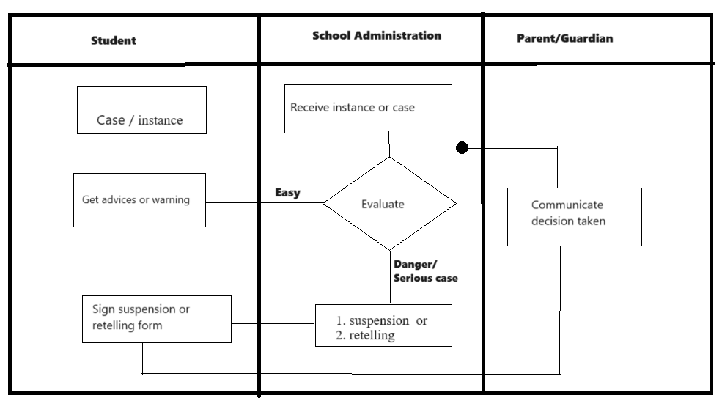
Figure 1: Modeling of the existing system

Problems of the Existing system
- The system heavily relies on manually processes: This means that many tasks and decisions are carried out using manual analysis and evaluation, such as social life challenges, study performance weakness etc. Manual handling of paperwork is time-consuming and prone to mistakes.
- Manual student performance: evaluation is labor-intensive and susceptible to human hard working, which can further delay in decision making.
- It is difficult for parent to track student school life and performance.
- It is difficult for school administration to communicate with students’ parents at a right time without any delays.

Proposed solutions
After analysis of problems facing the existing way of student intervention system at AUCA university we proposed to design and implement Education insight supporting hub which have possible keys functions that can solve the mentioned gaps, the system functionalities are listed below;
- Implement machine learning algorithms to analyze historical data and predict potential academic or social challenges for individual students.
- Set up an early warning system that identifies early signs of academic struggles or social issues.
- Trigger alerts for teachers, counselors, and parents when a student is identified by the system.
- Create profiles for each student, including academic history, attendance, behavior records, and social interactions.
- Provide teachers with dashboards highlighting key indicators of student performance and behavior.
- Facilitate communication and collaboration among teachers, counselors, and parents.
- Provide parents with a secure portal to monitor their child's academic progress, attendance, and social interactions.
- Send proactive alerts and suggestions for supporting their child's well-being.
- Suggest academic support, counseling sessions, or other relevant interventions.
- Enable continuous tracking of the effectiveness of interventions and improvements in student performance and Adjust strategies based on ongoing data analysis.
- Implement a secure communication platform for teachers, counselors, and parents to collaborate and discuss intervention strategies.
- Allow quick access to student profiles and intervention recommendations.
- Integrate a survey module to gather feedback from students on their academic experience and well-being and Use feedback for continuous improvement of support strategies.
- Generate reports and historical trends to identify patterns and areas for systemic improvement in the education system.

Requirement Specifications
System requirements are a declaration of the functionality a system must have in order to meet the needs of the client. Functional requirement defines a function of a system or its component, where a function is described as a specification of behavior between inputs and outputs. Nonfunctional Requirements define system attributes such as security, reliability, performance, maintainability, scalability, and usability.

Functional requirements of the proposed system
The system has the following functional requirement:
IT Administrator/ Admin
- Manage the technical aspects of the platform, including security, updates, and system maintenance.
- Provide user support and troubleshoot technical issues.
School Administrators
- Oversee the overall implementation and effectiveness of the support system.
- Access aggregated data and reports to inform policy decisions.
- Ensure compliance with educational standards and regulations.
Students
- Participate in surveys and provide feedback on their educational experience.
- Access resources and support recommended by the system.
- Engage in interventions designed to address academic or social challenges.
Teachers
- Access dashboards to monitor the academic and social performance of students.
- Receive alerts and recommendations for specific interventions.
- Collaborate with counselors, parents, and support staff to address student needs.
Counselors
- Utilize a dedicated portal for in-depth analysis of student data.
- Receive alerts on students requiring social or emotional support.
- Recommend and implement targeted interventions.
- Use behavioral analysis features to identify potential social challenges.
Parents/Guardians
- Access a secure portal to monitor their child's academic progress and well-being.
- Receive timely notifications, alerts, and intervention suggestions.
- Collaborate with teachers and counselors to support their child.

Non-Functional requirements of the proposed system.
The following are Non-functional requirements of Education insight supporting hub;
Performance
- The system should have low latency and provide quick responses to user requests.
- System should utilize system resources efficiently, such as CPU and memory, to ensure optimal performance and minimize resource consumption.
Scalability
- System should be designed to easily scale horizontally by adding more instances or nodes to accommodate increasing user demands.
Portability
- System should be developed in a way that allows it to be deployed and run on different platforms, such as various operating systems without requiring significant modifications.
Reliability
- System should be resilient to failures, including hardware or software failures, and be able to recover gracefully without significant disruption to the system or loss of data.
Maintainability
- System should be designed with a modular architecture, making it easier to understand, modify, and maintain individual components without impacting the entire system.
Security
- System should provide strong mechanisms for user authentication and authorization, ensuring that only authorized individuals can access sensitive functionalities or data.

CHAPTER 3

REQUIREMENTS ANALYSIS AND DESIGN OF THE NEW SYSTEM

Introduction
System analysis assists in understanding how and what a given system does. Design specifying a system's architecture, components, modules, interfaces, and data to satisfy defined requirements. This phase would be required to explain what the new system would do and how it would operate. The review of the existing system will be used to determine what changes will be required to accommodate the user needs that were not addressed by the previous one.
The development of a system requires time, much effort and attention. The purpose for building a new system is to fulfill the needs of its users and solve all the needs while using the existing system. Strong analysis of user’s needs will most of the time lead to a useful software development as a system might give perfect results.

Analysis and Design Methodology Object-oriented Methodology (OOM)
The term "object-oriented methodology" refers to a technique for creating software, applications, or systems. Object-Oriented Methodology (OOM) is a systematic approach to software development that emphasizes modeling real-world entities as objects and defining their interactions, promoting modularity, reusability, and maintainability. OOM involves phases such as analysis, design, and implementation, with a primary focus on breaking down complex systems into smaller, more manageable components.
During the analysis phase, requirements are gathered and analyzed to identify objects and their relationships within the system, while the design phase refines these objects into classes encapsulating data and methods, specifying interactions using inheritance and composition. OOM supports iterative development and fosters a clear understanding of system requirements, facilitating the creation of flexible, scalable software solutions (Booch, 2019)

Unified modeling language (UML)
Unified Modeling language (UML) is a standardized modeling language that enables the developers to specify, visualize, construct and document artifacts of a software system. Thus, UML makes these artifacts scalable, secure and robust in execution. UML is a crucial aspect involved in object-oriented software development. It was initially started to capture the behavior of complex software and non-software systems and now it has become an OMG standard. UML is designed to enable users to develop an expressive, ready to use visual modeling language. In addition, it supports high level development concepts such as frameworks, patterns and collaborations (Fowler, 2019).

UML models
UML models are visual representations used in software engineering to represent the structure and interactions of systems using Unified Modeling Language (UML). These models employ various diagrams such as class diagrams, sequence diagrams, and activity diagrams to capture different aspects of the system's design and functionality, facilitating communication among stakeholders and guiding the development process (Grady Booch, 2015).

Design of the new system
Designing a new system involves several key steps to ensure its effectiveness and efficiency. Analysis of requirements must be conducted to understand the needs and objectives of the system's users. The system architecture is designed, defining its structure, components, and interactions. System design involves detailing the architecture, components, modules, interfaces, and data of a system to fulfill predefined requirements.

Use Case Diagram
A use case is a methodology used in system analysis to identify, clarify, and organize system requirements. The use case is made up of a set of possible sequences of interactions between systems and users in a particular environment and related to a particular goal. The use case should contain all system activities that have significance to the users. A use case can be thought of as a collection of possible scenarios related to a particular goal.
A use case is the description of the model "View" by the actors in the system. It corresponds to the expected needs of each actor (the WHAT and WHO). Use cases are used to represent the operation of the system vis-à-vis the user, so this is a view of the system in its external environment.
In broader system analysis, a use case serves as a methodology to identify, clarify, and organize system requirements. It comprises a series of potential interactions between systems and users within a specific context and towards a particular objective. Each use case encompasses all significant system activities relevant to the users, presenting a collection of scenarios associated with achieving a specific goal.
Elements
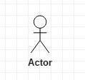
Actor: is a user that interacts with a system. An actor can be a person, an organization, or an outside system that interacts with your application or system. They must be external objects that produce or consume data.

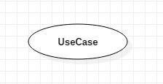
Use Case: it describes a function that a system performs to achieve the user’s goal. A use case must yield an observable result that is of value to the user of the system.

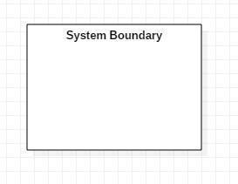
System Boundary: A system boundary separates actors outside of the system from use cases that are within the system. The diagram's optional system boundary does not provide any additional semantic meaning.
The following describe the relationships that you can use in use-case diagrams:
- Association: An association in a UML model is a connection between two classifiers, such as classes or use cases, that explains why they are connected and how their relationship is governed.
- Generalization: A generalization relationship in UML modeling is a connection where one model element (the offspring) is dependent on another model element (the parent). In class, component, deployment, and use-case diagrams, generalization relationships are used to show that the child inherits all of the traits, operations, and relationships defined in the parent
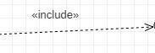
- Include: Include relationship is a relationship in which one use case (the base use case) includes the functionality of another use case (the inclusion use case). They include relationships that support the reuse of functionality in a use-case model.
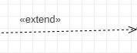
- Extend relationship: In UML modeling, you can use an extend relationship to specify that one use case (extension) extends the behavior of another use case (base). This type of relationship reveals details about a system or application that are typically hidden in a use case. (IBM, 2021). The extend relationship in UML modeling allows for the specification of additional behavior that occurs under specific conditions.

Use Case Diagram of the system
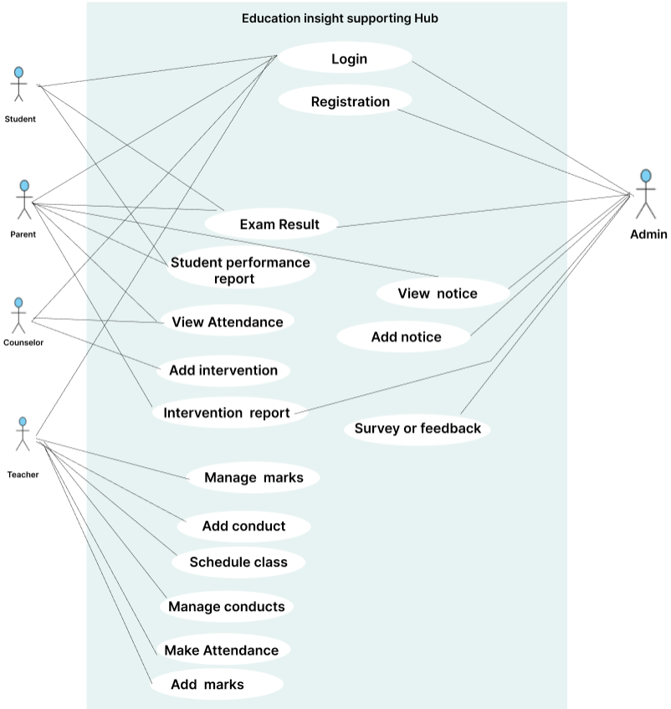
Figure 2: Use-Case Diagram
Use Case Description:
A use-case description outlines the functionality and requirements of a specific use case within a system. Each use case typically includes the following elements:
- Name: The title of the use case.
- Description: An explanation of the intended actions of the system.
- Actor: The individual or entity involved in the execution of the use case.
- Pre-condition: The initial system state required for the use case to commence.
- Post-condition: The system states upon completion of the use case.
- Normal flow: The sequential steps involved in the typical execution of the use case.
- Alternative flow: Optional steps that may occur if the normal flow encounters obstacles or deviations.
Use case description for Login
Name: Login
Actor: User (Staff, Student, Admin, parent, counselor)
Description: This allows all actors to access their dashboards.
Normal flow:
Login to the dashboard
- The Administrator and user which might be staff or students request the page to enter
the credentials
- The Administrator and users enter the credentials
- The system validates the credentials
- The system goes to the dashboard
Alternative flow
1.1 When A system fails to verify User credentials, it displays an error message
Table 1 : Use Case description on login
Use case description for add intervention
Name: add intervention
Actor: counselor, teacher, parent
Description: This allows a user to register to the system.
Normal flow: Make interventions
- The user might request the page to enter
the credentials
- The user makes interventions
- The system keeps the data.
- The system goes to interventions form and display it.
Alternative flow
1. When A system fails to add interventions, it displays an error message
Table 2 : Use Case description add interventions
Use case description for Register
Name: Request Acquisition
Actor: User (Staff or Student)
Description: This allows a user to request acquisition of an asset
Normal flow:
Request the Acquisition
- The User Request for the acquisition screen
- The system sends them to the acquisitions list which has the new request pending.
Alternative flow
1.1 When A system fails to do an acquisition request, it displays an error message
Table 3: Use Case description on Request Acquisition.

Class diagram
A class diagram in the Unified Modeling Language (UML) is a form of static structural diagram that depicts a system's classes, their properties, operations, and relationships between objects to explain the structure of the system.
What is a Class?
A description of a set of items having related functions in the system, which include:
Structural features define what objects of the class "know"
- Indicate a class object's state.
- Are demonstrations of a class's static or structural characteristics
Behavioral features (operations) define what objects of the class "can do"
- Describe the possible interactions between objects.
- Operations are descriptions of a class's dynamic or behavioral properties.

Class Notation
The class notation has three components.:
Class Name
- The class name can be found in the first division.
Class Attributes
- It displays attributes in the second partition.
- After the colon, the attribute type is displayed.
- In coding, attributes correspond to member variables (data members).
Class Operations (Methods)
- The third division displays operations. They are offerings that the class makes.
- A method's return type is displayed at the conclusion of the method signature, following the colon.
- After the colon that follows the parameter name, the return type of the method's parameters is displayed. In coding, operations correspond to class method
Elements
Class Name
Attributes-Name
+ Operations-Name()

Inheritance (or generalization)
One of the fundamental ideas in (OOP) languages is inheritance. It is a mechanism that allows you to create a hierarchy of classes that share a set of properties and methods by deriving a class from another class. An "is-a" relationship is represented by it. (Stackify, 2017)

Association
Through their shared objects, association builds a connection between two distinct classes. One-to- one, one-to-many, many-to-one, and many-to-many relationships are all possible.
Aggregation
Aggregation is the other form of association and is similar to composition. In aggregation, a container object again has several references to other objects. But aggregation is looser than composition. The objects' life cycles are not bound to each other in aggregation. Thus, the referring object may get destroyed before/after the referenced object.

Composition
Composition is a form of association that occurs when an object's life is tightly bound to another object's life. When the main object dies (i.e., is deleted), all the objects that are associated with that object also die. This means that the referenced object is solely contained by the referring object.

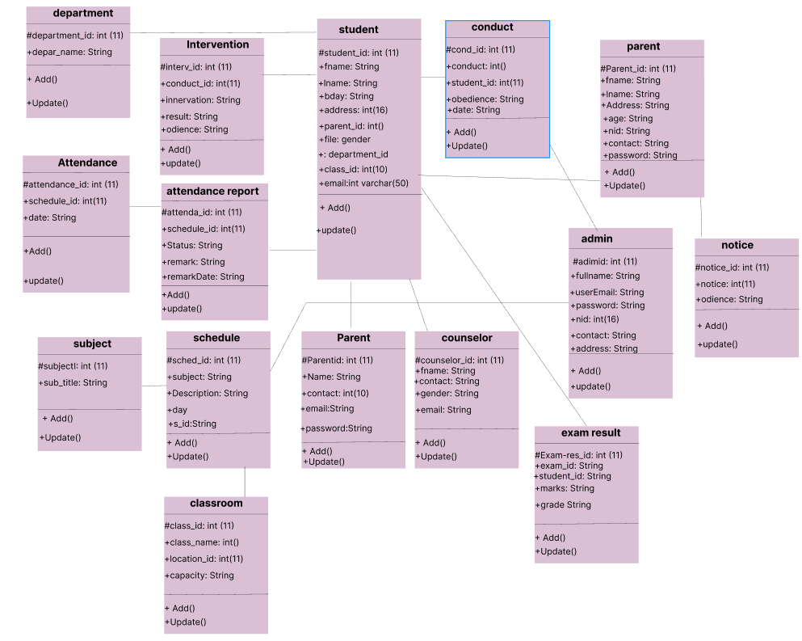

Figure 3: Class Diagram

Sequence diagram
A sequence diagram is a type of interaction diagram in the Unified Modeling Language (UML) that illustrates how objects interact in a particular sequence of events or operations within a system. It captures the order of messages exchanged between various objects, detailing the interactions over time. Sequence diagrams are used to visualize the flow of control and data among system components, making them essential for understanding the dynamic behavior of a system, identifying potential issues, and designing detailed interactions between system elements. (Larman, 2022).
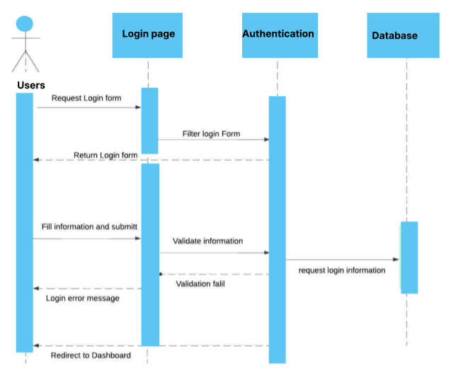
Figure 4: Login Sequence Diagram
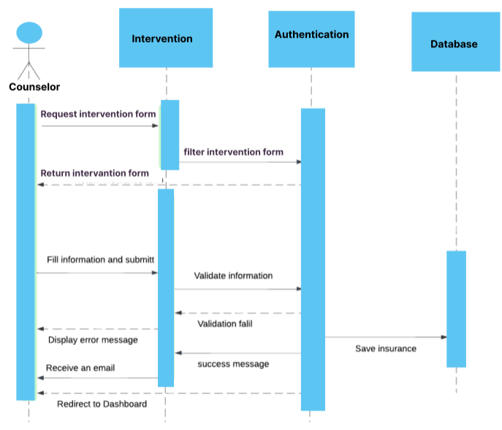
Figure 5: Make intervention Sequence Diagram
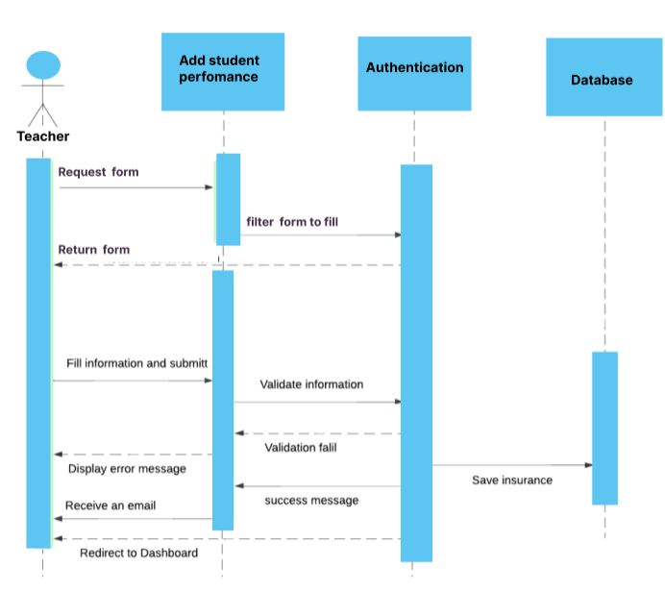
Figure 6:Add student performance Sequence Diagram
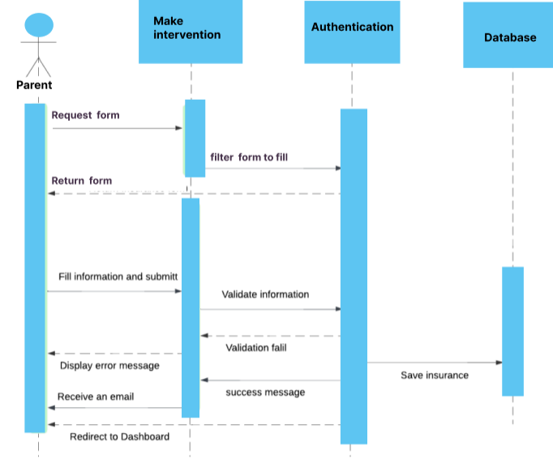
Figure 7:Make intervention Sequence Diagram

Database Schema diagram
A Database Schema diagram outline the structure of the database, including tables, columns, relationships, and constraints relevant to managing data throughout its lifecycle. It visually represents how different entities are organized within the database and how they are interconnected. This diagram serves as a blueprint for designing and understanding the database architecture of the system (Hernandez, 2013).
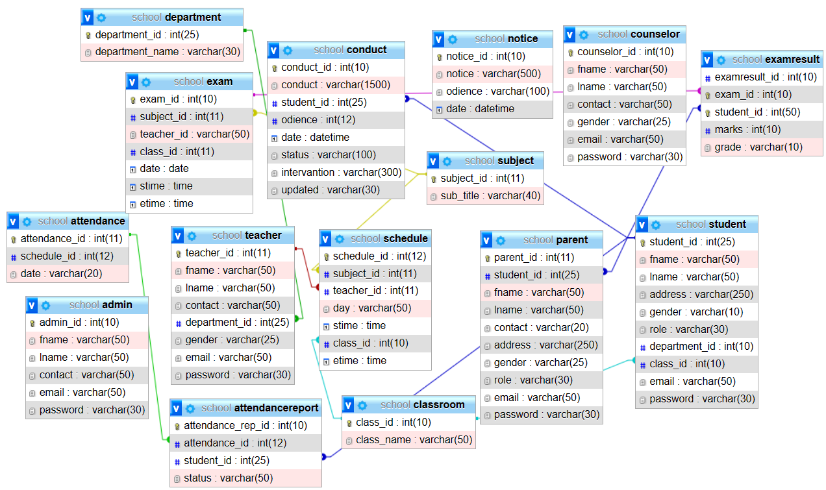

Figure 8: Database Schema

System Architecture Design
System Architecture Design involves the strategic planning and structuring of the system's components and interfaces to achieve the desired functionality, performance, and scalability while meeting the specified requirements and constraints. This process begins with a comprehensive analysis of the system requirements, stakeholders' needs, and environmental factors. The design phase entails breaking down the system into smaller manageable components, defining their responsibilities and interactions, and establishing the overall system structure. It also involves selecting appropriate architectural styles, patterns, and technologies to ensure that the system meets its objectives efficiently and can adapt to future changes.
An essential aspect of system architecture design is the consideration of various architectural viewpoints, including functional, structural, behavioral, and deployment perspectives. These viewpoints help stakeholders understand different aspects of the system and facilitate communication among team members, ensuring that everyone has a clear understanding of the system's design and its implications. Throughout the design process, architects must balance conflicting requirements and make trade-offs between different architectural qualities such as performance, reliability, security, and maintainability to achieve an optimal solution (Burns, 2017).
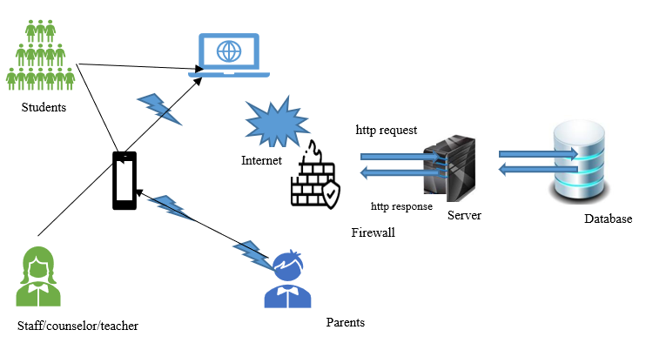
Figure 9: System Architecture Design

This architecture enables users to access and interact with the system through web browsers on laptops or smartphones, with the web server serving as the intermediary for processing user requests and serving web pages, and the database server handling data storage and retrieval.

CHAPTER 4

IMPLEMENTATION OF THE NEW SYSTEM

Introduction
The fourth chapter gives a brief overview of the tools and technologies used to build the application, the presentation pictures of the designed system, tests that were carried out and the compatibility and analysis requirements.

Technologies used
For implementing Education Insight supporting Hub the following tools were used.
Software | Product
Programming languages | PHP (For backend)  HTML (For fronted)  CSS (Frontend)
Integrated development environment | Visual Studio Code (For code editor)
Database Server | MySQL (XAMMP). for localhost server and database)

PHP
PHP is an open-source server-side scripting language that many devs use for web development. It is also a general-purpose language that you can use to make lots of projects, including Graphical User Interfaces (GUIs).
HTML
The web app was built on a combination of PHP and HTML. The researcher used Sublime Text v3.1.1 – Build 3176, to code the app. PHP was used to process the data, and access the logic of web app, while HTML was used to Structure the pages.
CSS
CSS was used to style the pages of this app and theme the Entire app (give it the look it has). It was implemented through custom styles, Bootstrap v4.0.0 & MDB Free v4.5.0.
Visual Studio Code
This is a computer program made by Microsoft for Windows, Linux and MACOS that software developers use in the creation, debugging, maintaining and supporting numerous programs and applications. It is embedded with Git control, syntax highlight, intelligent code completion and code refactoring. As a source code editor, VS Code uses languages such as C++, C#, Java, Python, PHP, etc.
MYSQL
MySQL is an open-source relational database management system. As with other relational databases, MySQL stores data in tables made up of rows and columns. Users can define, manipulate, control, and query data using Structured Query Language, more commonly known as SQL.

Presentation of the new system
In this part I try to give screen shoot description that are taken from the system and shows how the system look like. The system includes three main parts; citizen account, land user account and system admin account.
- Welcome page
This is the initial landing page that our system users encounter when they first visit the application. It introduces users to the application's login, and signup for new users.
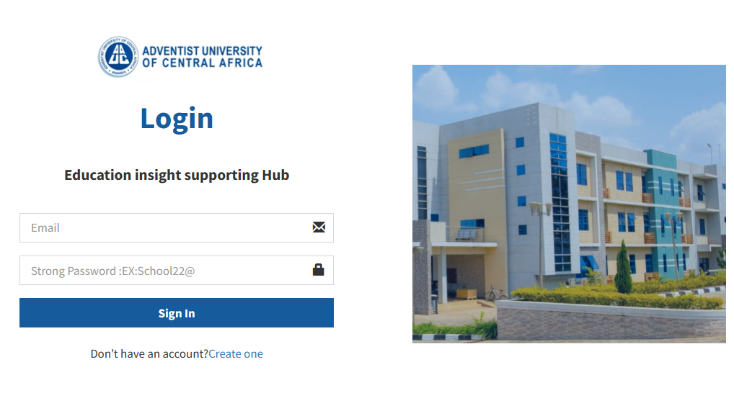
Figure 10: welcome page
2. Login form
All users have to login with username and password to enter in the system, if the username and password entered are not match, system gives him/her an error to use corrected username and password, and if is correct, system direct user to his/her dashboard.
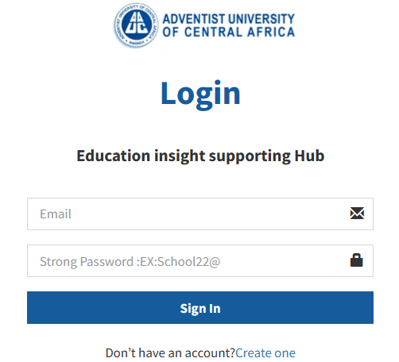
Figure 11: Login form
3. Users Registration form
Register form used by parent to create an account, while parent or student guardian creating account, he/she requires to have student registration number to make sure that is the real guardian of AUCA student.

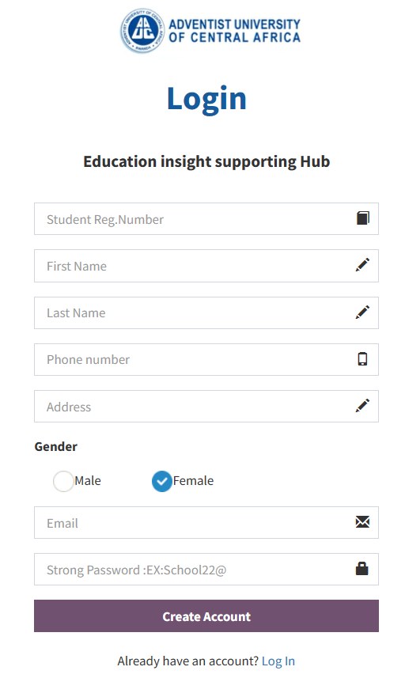
Figure 12: Parent Register form
4. Admin dashboard
This part designed for administrators/AUCA staff to monitor, manage, and analyze various aspects of a system. It provides a comprehensive view of user activities, system performance, reports and other relevant information that administrators need to make informed decisions and maintain the efficiency of the system.
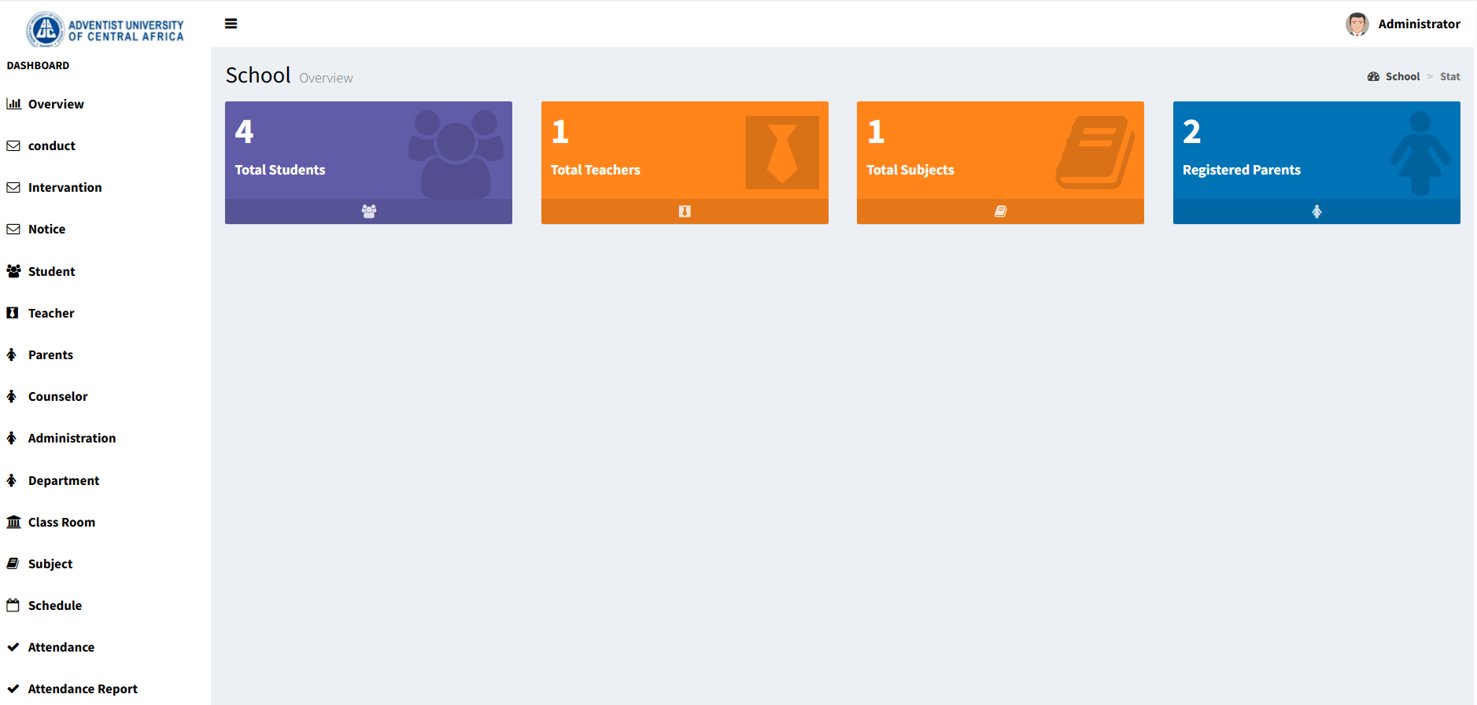
Figure 13: Admin dashboard
5. View student Attendance report

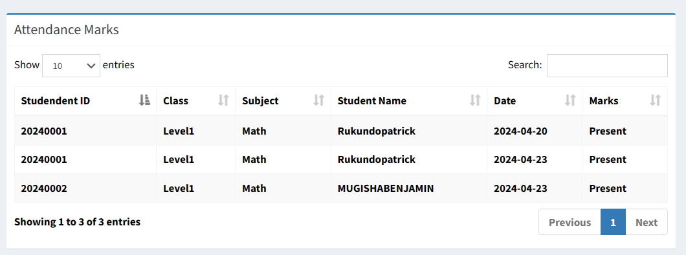
Figure 14: View student attendance report
6.Add student Marks
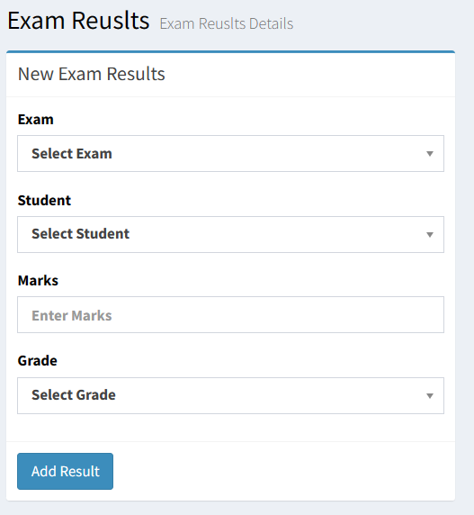
Figure 15: Add student marks
7.View student marks

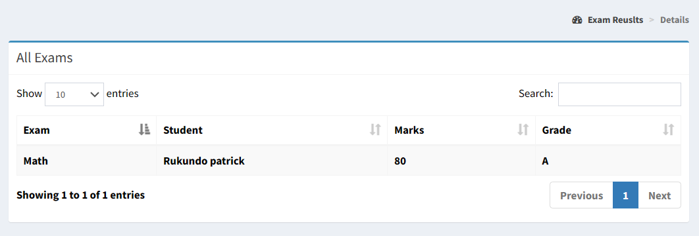
Figure 16: View student marks
8.Add notice
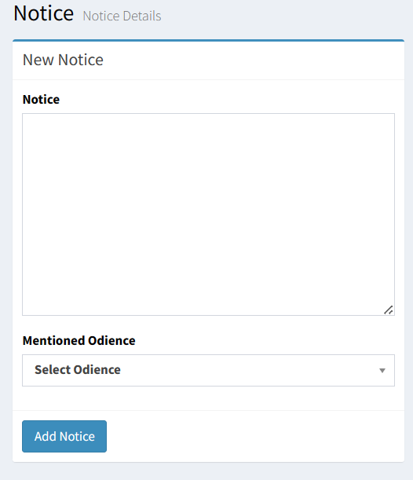
Figure 17: Add notice
9.View Notice
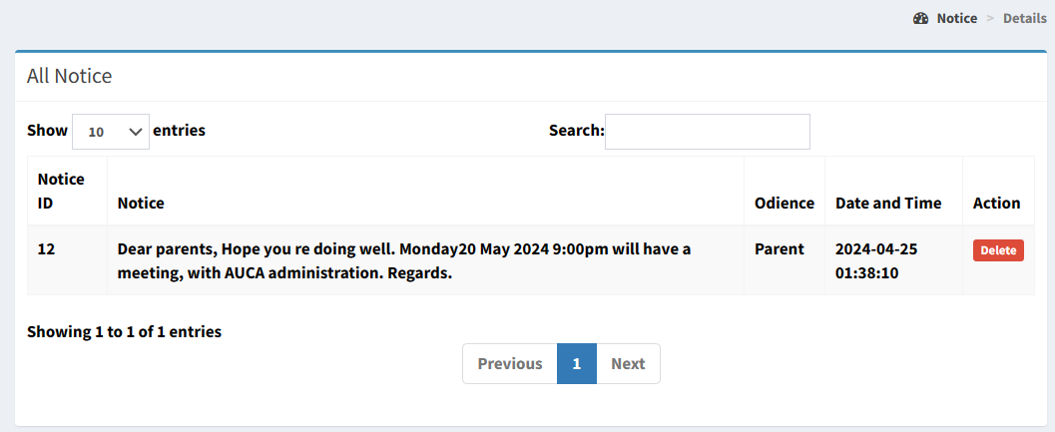
Figure 18 : View notice
10.Report student conduct
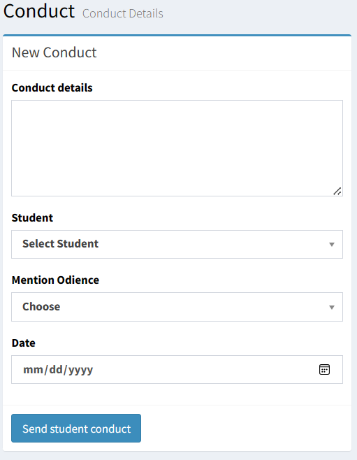
Figure 19: report student conducts
11. View students conducts
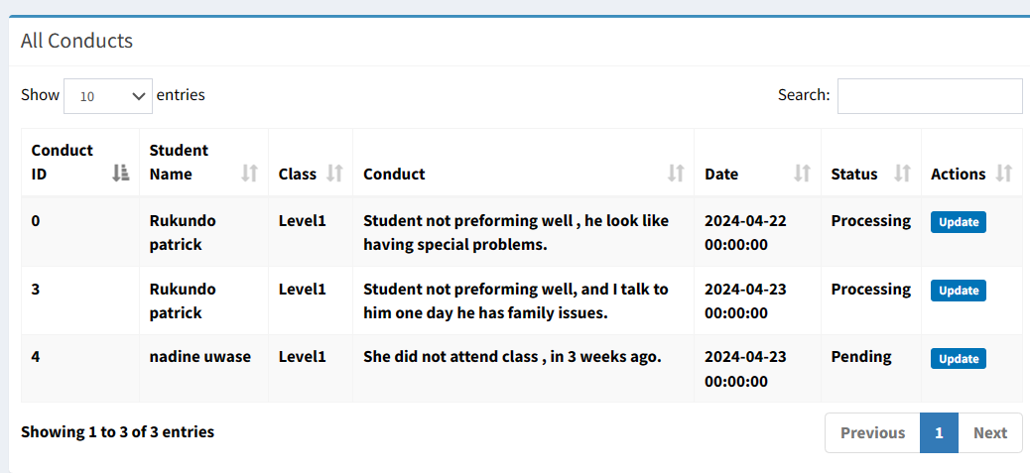

Figure 20 : View students conducts

12.Make intervention
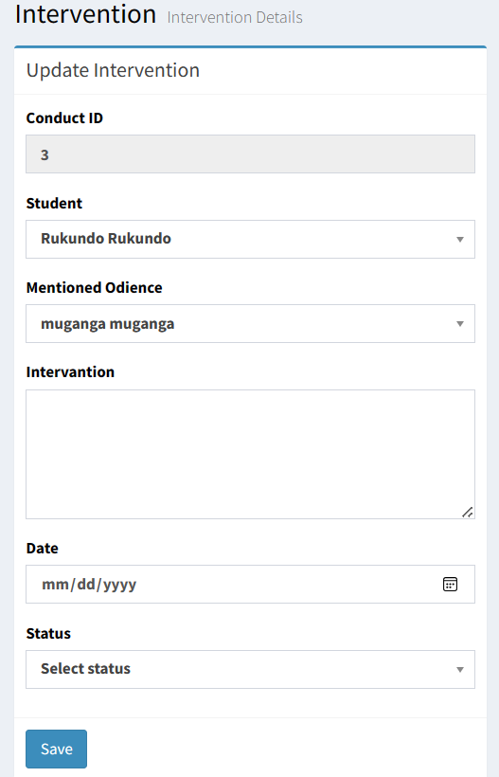
Figure 21: Make intervention

13.View interventions made
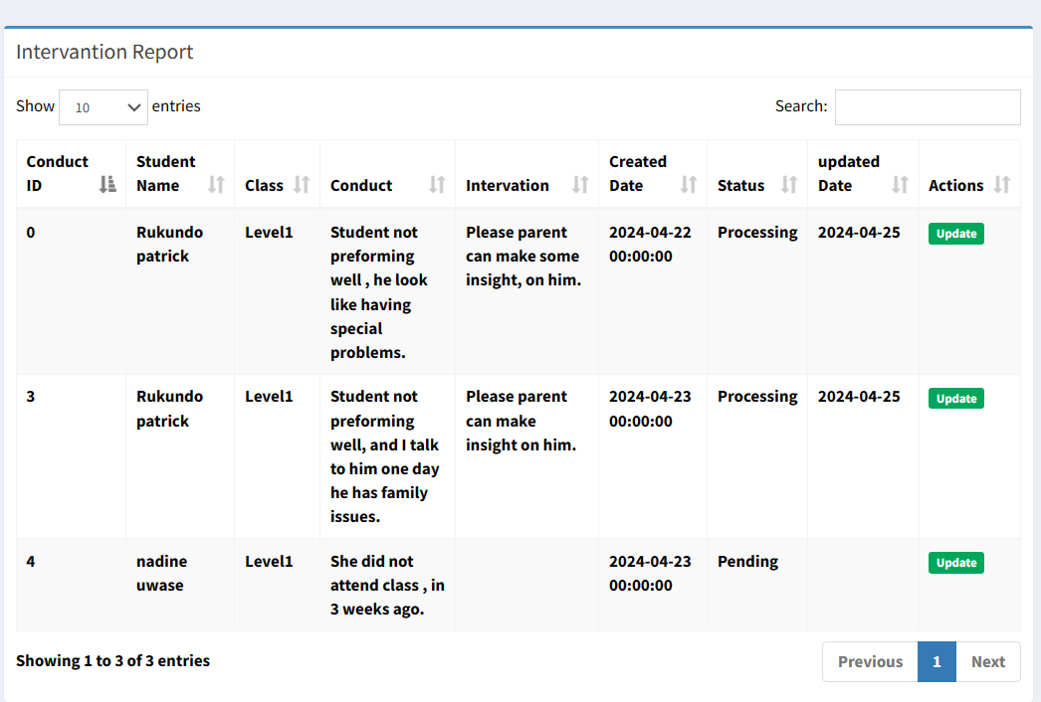
Figure 22: Interventions

Software Testing
Software testing plays a crucial role in software designing. Those roles include the help in verifying the effectiveness of the software to ensure its functionality. Here are the listed key areas to take into consideration during software testing.
- Does the application meet the essential requirements needed in design and development?
- Does the application work to its expected rate?
- Can the application be implemented with the same characteristics and satisfies the needs of the stakeholders?
The following are types of software testing.
The unit testing: This the process that ensures the proper functioning of a particular software or a portion of a program.
This is a method to which individual units of source code, sets of computer programs modules together with associated control data, usage procedures and operating procedures tested to determine if they are fit for use. This means every component is compiled with the goal to know every unit that matches to its specification to discover logical mistakes.
The integration test: this is a phase to which individual software modules are combined and tested as a group. This is essential in checking the assembly of a different part the software.
It is also a continuous progression of tests in which the software and hardware components are collected and tested until the entire system is tested. The application modules have been successively tested until completion to ensure that the whole constituted by the assembled software components responds to the required functional and technical specification.
The validation test: This is the final testing phase which carries the role of validating the software in its external environment. The product is placed in final phases to verify if it responds to the requirements needed in the first phase. This is why it is necessary.
The application that was tested entirely and it’s undertaking the progression of operations done corresponds to the functional specifications.

CHAPTER 5

CONCLUSION AND RECOMMENDATION

Conclusion
In summary, the "Education Insight Supporting Hub" is a comprehensive web application designed to empower educators, counselors, and parents with timely insights into students' academic and social well-being. At its core, the system utilizes advanced algorithms to analyze various data points, including academic performance, attendance records, and behavioral patterns, to identify early signs of academic struggles or social issues among students.

Through personalized profiles for each student, encompassing their academic history, attendance records, and behavior, the platform provides a holistic view of each student's journey, enabling stakeholders to intervene proactively.

One of the key features of the platform is its alert system, which automatically notifies teachers, counselors, and parents when a student is flagged by the system. The system successfully satisfying the requirements and has been shown that the system facilitates users using internet because it is an online system. System front end developed using HTML, CSS, and JavaScript. This will assist us in: create responsive and interactive user interfaces and for back end, PHP framework and MySQL database were used.

Recommendation
I recommend establishing an "Education Insight Supporting Hub" at AUCA to foster collaboration and innovation in education. This hub would serve as a centralized resource for faculty, students, staff and parent to exchange ideas, share best practices, and access professional development opportunities aimed at enhancing teaching and learning effectiveness.

I recommend launching a project focused on developing a series of research initiatives aimed at exploring innovative educational approaches, assessing their impact on student learning outcomes, and disseminating best practices within and beyond the university community.

REFERENCES

BOOKS
- Booch, G. (2019). Object-Oriented Analysis and Design with Applications.
- Burns, B. (2017). Designing Distributed Systems:.
- Flagg, M. (2023). What Is Structured Systems Analysis And Design Method (SSADM)?
- Fowler, M. (2023). A Brief Guide to the Standard Object Modeling Language.
- Grady Booch, J. R. (2015). The Unified Modeling Language User Guide.
- Groover, M. P. (2024). History & Society automation. The Editors of Encyclopaedia Britannica.
- Hernandez, M. J. (2013). A Hands-On Guide to Relational Database Design.
- Hoffer. (2018). Modern system analysis and design .
- Larman, C. (2022). An Introduction to Object-Oriented Analysis and Design and Iterative Development.
- Watt, A. (2014). Database Design - 2nd Edition. City University: BCcampus.

WEBSITES
- AUCA. (2022). Background , Mission and Vission. auca.ac.rw.
- Benitez. (2019, October 02). What is unit testing. Retrieved July 19, 2020, from searchsoftwarequality.techtarget.com: https://searchsoftwarequality.techtarget.com/definition/unit-testing
- brookings. (2024). Global education: How to transform school systems? brookings.edu/articles/global-education-how-to-transform-school-systems/.
- Woldbank. (2022). The World Bank Group is the largest financier of education in the developing world, working in 90 countries and committed to helping them reach SDG4: access to inclusive and equitable quality education and lifelong learning opportunities for all by 2030. https://www.worldbank.org/en/topic/education/overview.
- Bing. (2023). Introduction System architecture design. www.bing.com.
- oracle. (2022). What Is a Database? oracle.com.
- Russo, G. (2016, July 02). What is validation testing. Retrieved June 19, 2020, from tutorialspoint.com: http://www.tutorialspoint.com/software_testing_dictionary/validation_testing.htm
- Silberschatz, A. (2003). Database Systems. sciencedirect.com.
- Sparks, A. (2017, June 15). Database diagram. Retrieved 08 20, 2019, from altova: https://www.altova.com/umodel/uml-database-diagrams

APPENDIX

Curriculum Vitae.

